**Acompanhamento - Módulo 1 Fundamentos**

* **Capítulo 1**
  + [**Big data, Machine learning e Data mining**](https://igti.instructure.com/courses/2940/modules/items/190965) ⇒ **OK**
  + [**Data analytics, Data science e Business intelligence**](https://igti.instructure.com/courses/2940/modules/items/190966) **⇒ OK**
  + [**Algoritmo K-Means na prática**](https://igti.instructure.com/courses/2940/modules/items/190967) **⇒ OK**
    - **K-Means é um algorítmo de Machine Learning baseado em aprendizado não supervisionado;**
    - **Objetivo é encontrar simililaridade entre os dados e agrupá-los conforme o número de clusters (K)**
    - **Apresentação do *Google Colab***
* **Capítulo 2**
  + [**Processos e Técnicas: etapas do processo**](https://igti.instructure.com/courses/2940/modules/items/190968) **⇒ OK**
  + [**ETL**](https://igti.instructure.com/courses/2940/modules/items/190969) ⇒ **OK**
  + [**Data warehouse e Data lake**](https://igti.instructure.com/courses/2940/modules/items/190969) **⇒ OK**
  + [**Tipos de análises**](https://igti.instructure.com/courses/2940/modules/items/190970) **⇒ OK**
    - 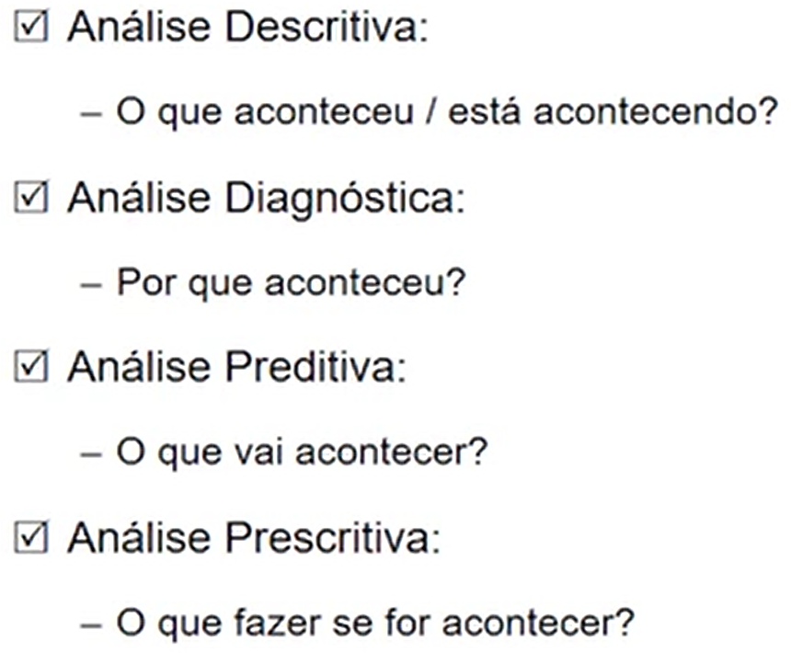
* [**Streaming e Visualização de dados**](https://igti.instructure.com/courses/2940/modules/items/190971) **⇒ OK**
* [**Prática com Power BI**](https://igti.instructure.com/courses/2940/modules/items/190972) **⇒ OK**

[**Primeira Aula Interativa do Módulo 1**](https://igti.instructure.com/courses/2940/modules/items/191021) **⇒ Prevista para o dia 20/05/2020**

* **Capítulo 3**
  + [**Computação em nuvem**](https://igti.instructure.com/courses/2940/modules/items/190978) **⇒ OK**
  + [**Processamento paralelo e distribuído**](https://igti.instructure.com/courses/2940/modules/items/190979) **⇒ OK**

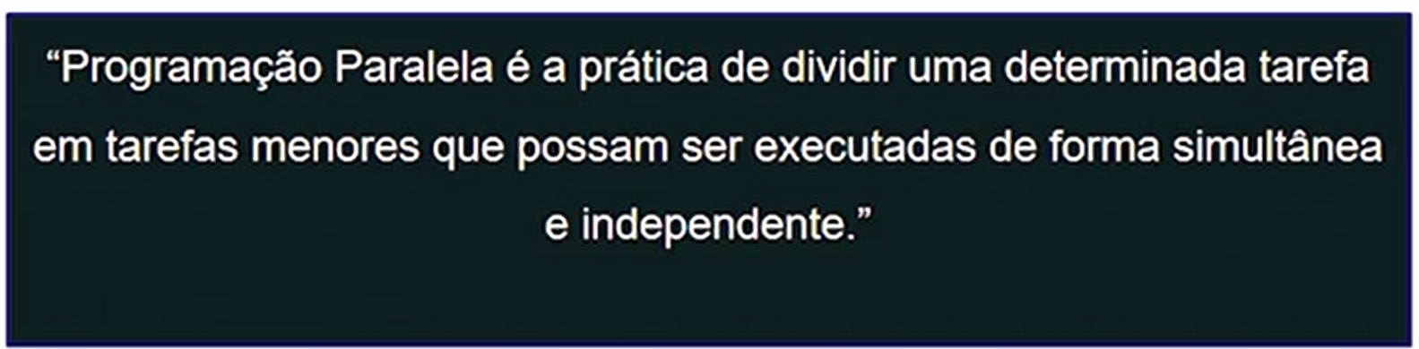

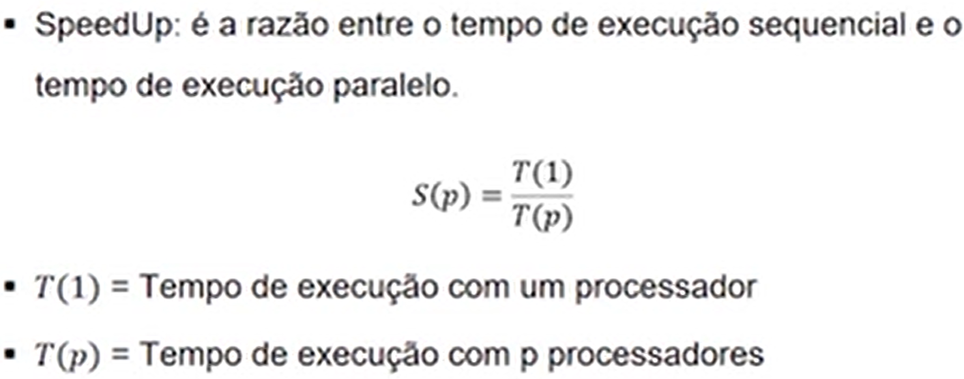

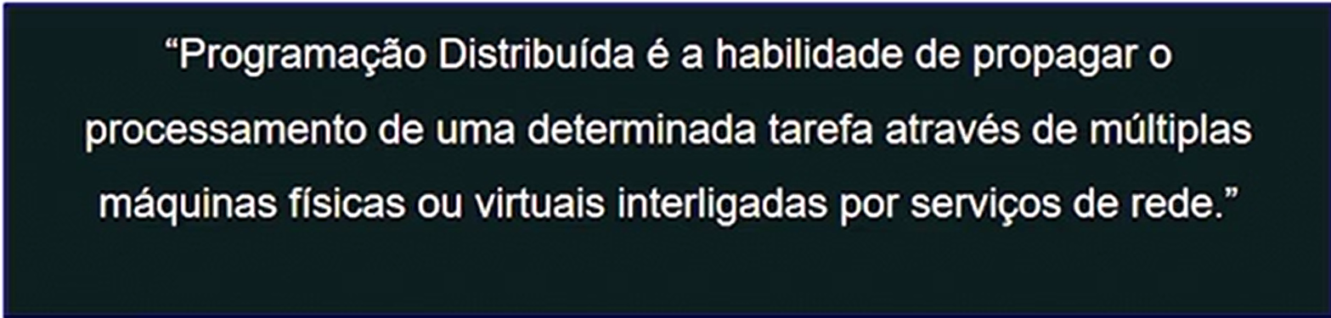

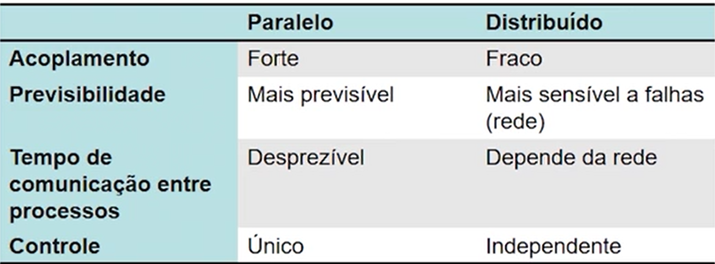

* [**Apache kafka e Hadoop spark**](https://igti.instructure.com/courses/2940/modules/items/190980) **⇒ OK**
* [**Bancos relacionais e não-relacionais (NoSQL)**](https://igti.instructure.com/courses/2940/modules/items/190981) **⇒ OK**
* [**Couchbase**](https://igti.instructure.com/courses/2940/modules/items/190982) **⇒ OK**
* [**Indústria 4.0**](https://igti.instructure.com/courses/2940/modules/items/190983)
* [**Regressão e correlação**](https://igti.instructure.com/courses/2940/modules/items/190984)
* [**Cases Big Data e Analytics**](https://igti.instructure.com/courses/2940/modules/items/190985)

[**Fórum de Dúvidas do Desafio 1**](https://igti.instructure.com/courses/2940/modules/items/190986)

[**Segunda Aula Interativa do Módulo 1**](https://igti.instructure.com/courses/2940/modules/items/191022) **⇒ Prevista para o dia 26/05/2020**